Real-Time Network Traffic

⏱️ What Is Real-Time Network Traffic?
# Source: AI Source: Provided by: [Data Path: Persons Table -> ID Column: 1, Name_En Column: Motasem Essam] -> From: [ChatGPT] on [12/18/2025]
Real-time network traffic refers to data that must be transmitted, delivered, and processed immediately or within milliseconds to be useful — typically without delay or buffering. This type of traffic is highly time-sensitive and is commonly used in voice, video, gaming, and control systems.

🧠 Simple Definition:
# Source: AI Source: Provided by: [Data Path: Persons Table -> ID Column: 1, Name_En Column: Motasem Essam] -> From: [ChatGPT] on [12/18/2025]
Real-time traffic is any network communication where delays or jitter can seriously affect quality or usability, because data must arrive on time.

📡 Common Examples of Real-Time Traffic
# Source: AI Source: Provided by: [Data Path: Persons Table -> ID Column: 1, Name_En Column: Motasem Essam] -> From: [ChatGPT] on [12/18/2025]
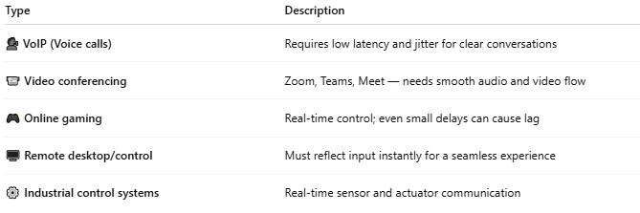
Type | Description
🗣️ VoIP (Voice calls) | Requires low latency and jitter for clear conversations
📹 Video conferencing | Zoom, Teams, Meet — needs smooth audio and video flow
🎮 Online gaming | Real-time control; even small delays can cause lag
🖥️ Remote desktop/control | Must reflect input instantly for a seamless experience
⚙️ Industrial control systems | Real-time sensor and actuator communication

⚠️ Characteristics of Real-Time Traffic
# Source: AI Source: Provided by: [Data Path: Persons Table -> ID Column: 1, Name_En Column: Motasem Essam] -> From: [ChatGPT] on [12/18/2025]
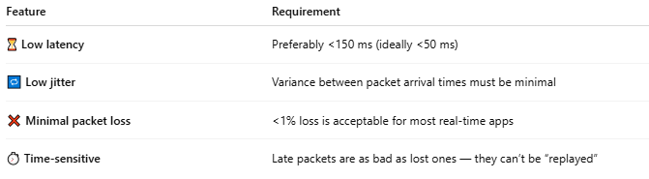
Feature | Requirement
⏳ Low latency | Preferably <150 ms (ideally <50 ms)
🔁 Low jitter | Variance between packet arrival times must be minimal
❌ Minimal packet loss | <1% loss is acceptable for most real-time apps
⏱️ Time-sensitive | Late packets are as bad as lost ones — they can’t be “replayed”

🔐 Protocols Often Used
# Source: AI Source: Provided by: [Data Path: Persons Table -> ID Column: 1, Name_En Column: Motasem Essam] -> From: [ChatGPT] on [12/18/2025]
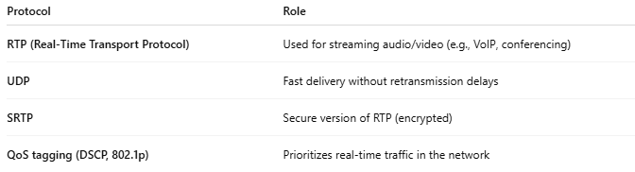
Protocol | Role
RTP (Real-Time Transport Protocol) | Used for streaming audio/video (e.g., VoIP, conferencing)
UDP | Fast delivery without retransmission delays
SRTP | Secure version of RTP (encrypted)
QoS tagging (DSCP, 802.1p) | Prioritizes real-time traffic in the network

🚦 Real-Time vs Non-Real-Time Traffic
# Source: AI Source: Provided by: [Data Path: Persons Table -> ID Column: 1, Name_En Column: Motasem Essam] -> From: [ChatGPT] on [12/18/2025]
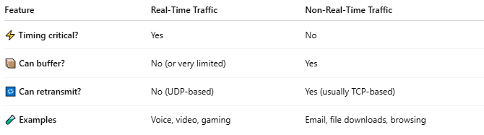
Feature | Real-Time Traffic | Non-Real-Time Traffic
⚡ Timing critical? | Yes | No
📦 Can buffer? | No (or very limited) | Yes
🔁 Can retransmit? | No (UDP-based) | Yes (usually TCP-based)
🧪 Examples | Voice, video, gaming | Email, file downloads, browsing

✅ How to Optimize Real-Time Traffic
# Source: AI Source: Provided by: [Data Path: Persons Table -> ID Column: 1, Name_En Column: Motasem Essam] -> From: [ChatGPT] on [12/18/2025]
- 🚦 Enable QoS (Quality of Service) to prioritize real-time traffic
- 📶 Use wired connections over Wi-Fi for stability
- 🛡️ Avoid congested networks and bandwidth-hogging apps
- 🧱 Separate voice/video on dedicated VLANs
- 🛰️ Use jitter buffers in VoIP and video apps

📌 Summary
# Source: AI Source: Provided by: [Data Path: Persons Table -> ID Column: 1, Name_En Column: Motasem Essam] -> From: [ChatGPT] on [12/18/2025]
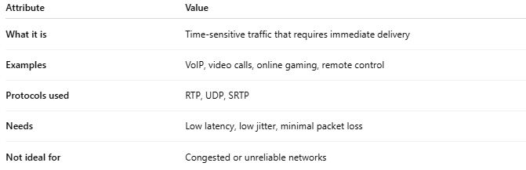
Attribute | Value
What it is | Time-sensitive traffic that requires immediate delivery
Examples | VoIP, video calls, online gaming, remote control
Protocols used | RTP, UDP, SRTP
Needs | Low latency, low jitter, minimal packet loss
Not ideal for | Congested or unreliable networks

